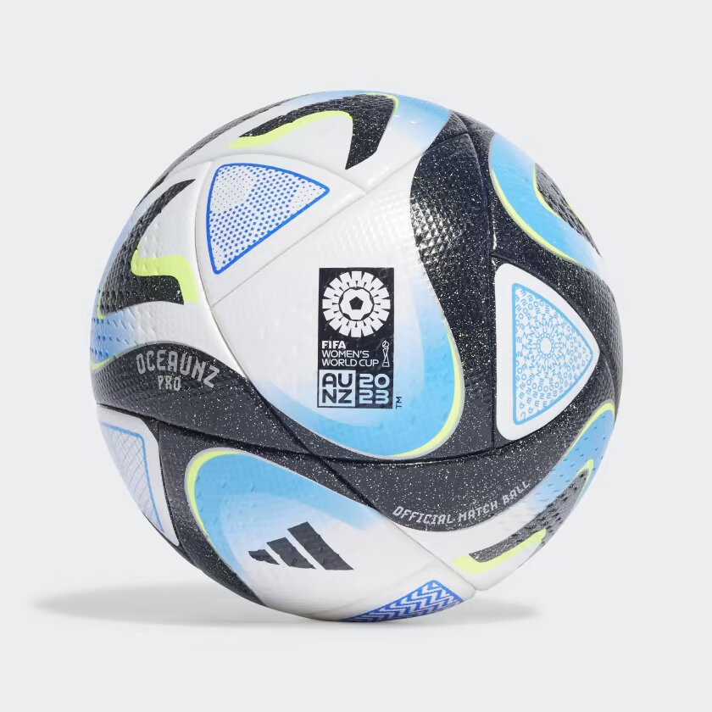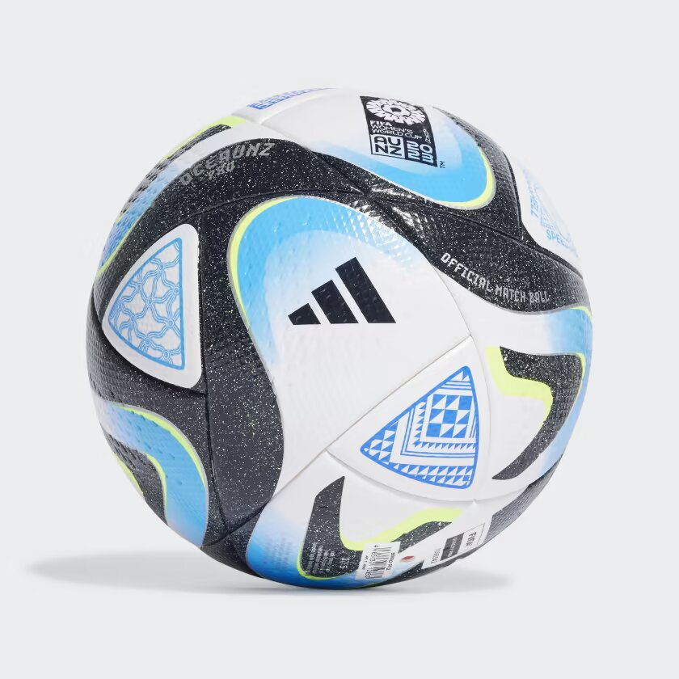

ADIDAS OCEAUNZ PRO FOOTBALL

**THE OFFICIAL MATCH BALL OF THE FIFA WOMEN'S WORLD CUP™.**

Created for flowing soccer. The official match ball used during the early stages of the FIFA Women's World Cup™, this adidas Oceaunz pro ball stands out with graphics that reflect the importance of Australia and New Zealand's spectacular coastlines and life-sustaining lakes and waterways. Its seamless construction makes for a predictable flight and bounce. That Quality Pro stamp is FIFA's highest rating.

**DETAILS:**

* 70% polyurethane, 20% recycled polyester, 10% viscose cover
* High-grade butyl bladder
* FIFA Quality Pro certified
* FIFA Women’s World CUP™ printed logo
* Requires inflation
* Imported
* Product color: White / Collegiate Navy / Bold Blue / Bright Blue
* Product code: HT9011